Weekly Construction Progress Report – Week 34
Harrow Bay Offshore Wind · 17 Aug – 23 Aug 2026
Elena Márquez · 24 August 2026 · HB-PM-RPT-2026-W34

1. Summary
1 monopile (HB-A12) was installed this week, bringing the total to 12 of 40. The foundation campaign is 2 piles behind the Rev 2 baseline (14 planned). Waiting on weather amounted to 21 hours.
Area | Status | Comment
Overall schedule | Amber | 12/40 monopiles vs. 14 planned
Foundations | Amber | TPs installed: 11
Offshore substation | Green | Topside installed 19 Aug
Cables | Red | Export cable 2 delay – HB-RISK-017
HSE | Green | No incidents

2. Progress
Metric | This week | Cumulative | Plan (cum.) | Variance
Monopiles installed | 1 | 12 | 14 | -2
Transition pieces installed | 0 | 11 | – | –
Waiting on weather (h) | 21 | 306 | – | –
Persons on board (avg.) | 102 | – | – | –
Man-hours MV Sea Atlas | 8,712 | 161,733 | – | –
Lost time injuries | 0 | 0 | 0 | 0
Recordable injuries | 0 | 1 | – | –
Near misses reported | 0 | 4 | – | –
HSE observation cards | 16 | – | – | –

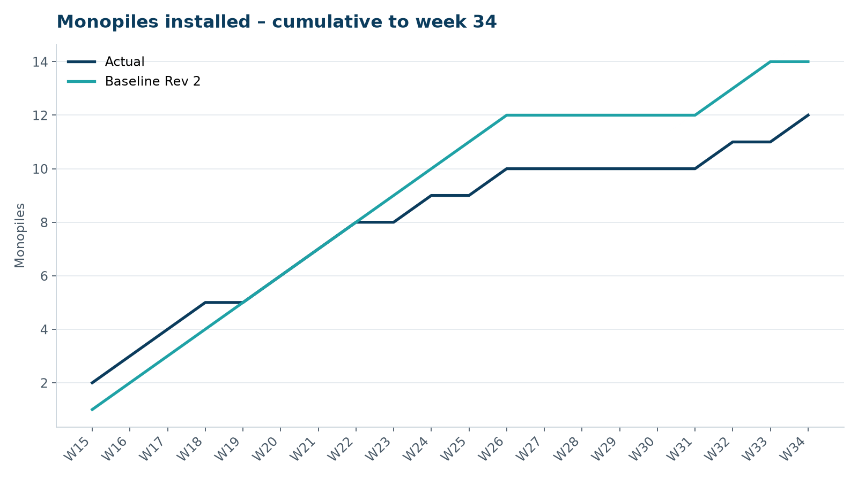
Figure 1 – Monopile installation progress, W15 to W34

3. Key activities this week
- Offshore substation topside installed on 19 August – a major project milestone.
- MV Sea Atlas held outside the exclusion zone during the lift (18–20 August).
- HB-A12 installed on 23 August.

4. Health and safety
No lost time injuries. 16 observation cards submitted; top theme: line-of-fire during lifts.

5. Environment
- HB-A12: peak 159.1 dB SEL at 750 m (compliant); harbour porpoise detected in the mitigation zone during the pre-piling search, soft start delayed by 20 min.

6. Issues and risks
- HB-RISK-017 export cable 2 delay – recovery programme received; resequencing of cable lay campaign in progress.
- HB-RISK-001 weather: 21 h downtime this week.

7. Look-ahead next week
TP HB-A12; load-out of HB-A14, HB-B01 and HB-B02.
Prepared by Project Controls (Gareth Lewis); approved by Elena Márquez. Distribution: project team, Steering Committee, Halden Turbine Systems, Lenders' Technical Adviser.

